COUNTY OF SAN DIEGO
invites applications for the position of:

Supervising Environmental Health Specialist-FHD-19472604FHD

SALARY: | $76,564.80 - $94,120.00 Annually
OPENING DATE: | 05/10/19
CLOSING DATE: | 05/26/19 11:59 PM
JOB SUMMARY:
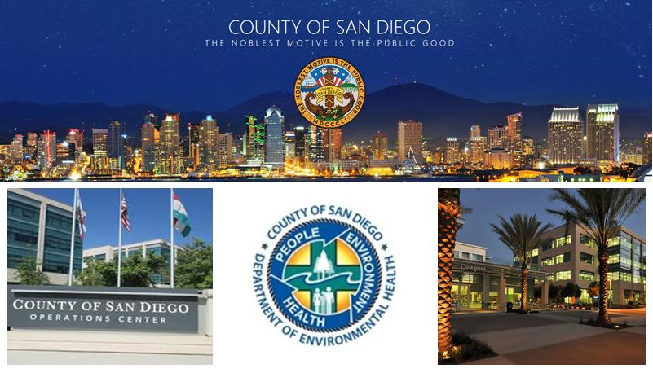
This is a series recruitment that may be subject to suspend on May 26, 2018, at 11:59 p.m.
PER COUNTY RULES, THIS POSITION IS ELIGIBLE FOR APPOINTMENT AT STEP 1 $76,564.80 ANNUALLY. COUNTY EMPLOYEES ARE SUBJECT TO THE COUNTY PROMOTIONAL RULE FOR STEP PLACEMENT IN ACCORDANCE WITH COMP ORD 1.3.5.
The Department of Environmental Health is seeking qualified Supervising Environmental Health Specialist candidates for their Food and Housing Division.
Supervising Environmental Health Specialists are responsible for supervising, planning, and coordinating the work of a unit of employees that implement environmental health programs through permitting, inspection, education, consultation, planning, investigation, and enforcement activities in a wide variety of areas including food, housing, water quality, recreational health, land use, site assessment and mitigation, solid waste and hazardous materials.

The Food & Housing Division seeks to increase life expectancy and the quality of life by promoting public health and safety for the 3.3 million residents of San Diego County and the more than 17.4 million overnight guests that visit the County each year. Our commitment is embedded in our goals and objectives that focus on reducing risks that can lead to foodborne illness. The purpose of the housing program is to ensure safe housing such as rental units in regulated areas of the County. To accomplish this, the Food and Housing Division enforces state laws pertaining to sanitation, maintenance, ventilation, and occupancy. The Food & Housing Division also focuses on recreational health associated with the use of public swimming pools, spas, and spraygrounds, focusing on health and safety concerns to prevent drownings and water borne illnesses.
Click DEH for additional information on the County of San Diego - Department of Environmental Health.
Click here to review the complete job description including the minimum qualifications, examples of duties, essential functions, etc.
Minimum Requirements:
1. A bachelor's degree from an accredited U.S. college or university, or a certified foreign studies equivalency, with at least 30 semester units of basic biological, physical, or environmental science courses which must have included one or more laboratory courses in chemistry, physics, microbiology, biology, and one or more mathematics courses in college algebra or higher math, AND, six (6) years of experience as an environmental health professional with a recognized public environmental agency or private environmental organization or company, at least three (3) years of which must have been at the lead level; OR,
2. Four (4) years of experience as an Environmental Health Specialist II in the County of San Diego; OR,
3. Three (3) years of experience as an Environmental Health Specialist III in the County of San Diego.
Note: Possession of a master's degree from an accredited U.S. college or university, or a certified foreign studies equivalency, in a science field such as biology, chemistry, environmental health, environmental engineering, ecology, or geology may be substituted for the required experience on a year-for-year basis.
Licenses and Certificates:

Certification as a Registered Environmental Health Specialist by the State of California (California Health and Safety Code) is required.
Required Attachments:
1. A copy of your unalterable transcripts from an accredited U.S college or university, or a copy of a certified foreign studies equivalency must be submitted at the time of application.
2. A copy of the current and valid Registration as an Environmental Health Specialist with the State of California.
Evaluation Process
Qualified applicants will be placed on a twelve (12) month employment list based on scores received during the evaluation of information contained in their employment and supplemental applications. Please ensure all information is accurate and complete, as the responses you provide on the supplemental application questionnaire will be reviewed using an automated evaluation system. If you are successful in the initial screening process, your application will be reviewed individually to confirm that the information you provided is accurate and qualifying.

Reasonable accommodation may be made to enable qualified individuals with disabilities to perform the essential functions of a job, on a case-by-case basis.

The County of San Diego and its employees embrace the Live Well San Diego vision: A region that is Building Better Health, Living Safely and Thriving. Click here for more information www.livewellsd.org.

Under California Government Code Sections 3100 - 3109, public employees are designated as disaster service workers. The term "public employees" includes all persons employed by the state or any county, city, state agency, or public district. Disaster service workers are required to participate in such disaster service activities as may be assigned to them by their employer or by law.

The County of San Diego is committed to valuing diversity and practicing inclusion because our diverse workforce is our greatest asset and our customers are our number one priority.

APPLICATIONS MAY BE FILED ONLINE AT:  http://www.SanDiegoCounty.Gov  5530 Overland Ave., Suite 210  San Diego, CA 92123  (619) 236-2191  (866) 880-9374  processunitemail.fgg@sdcounty.ca.gov | Position #19472604FHD  SUPERVISING ENVIRONMENTAL HEALTH SPECIALIST-FHD-19472604FHD  CP

