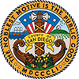 | COUNTY OF SAN DIEGO  invites applications for the position of:  Supervising Environmental Health Specialist-19472602HMD

SALARY: | $76,564.80 - $94,120.00 Annually
OPENING DATE: | 02/19/19
CLOSING DATE: | 03/10/19 11:59 PM
JOB SUMMARY:
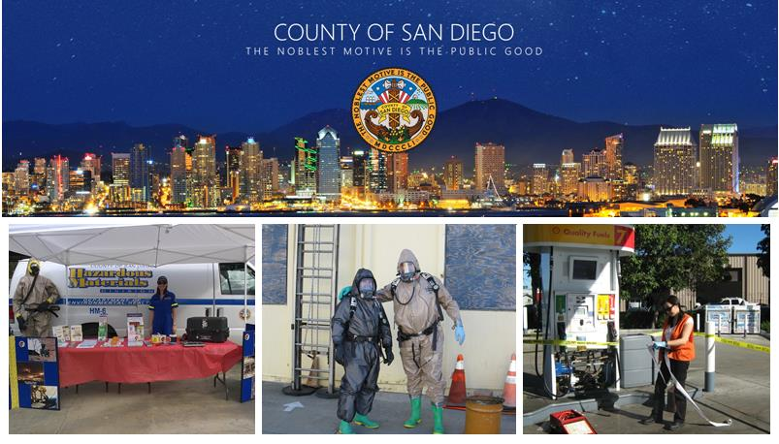

County of San Diego - Department of Environmental Health
SUPERVISING ENVIRONMENTAL HEALTH SPECIALIST
Hazardous Materials Division
This is a series recruitment that may suspend on Sunday March 10, 2019, at 11:59 p.m.
PER COUNTY RULES, THIS POSITION IS ELIGIBLE FOR APPOINTMENT AT STEP 1, $76,564.80. County employees are subject to the County Promotion Rule for Step Placement in Accordance with Comp Ord 1.3.5.
Supervising Environmental Health Specialists are responsible for supervising, planning, and coordinating the work of a unit of employees that implement environmental health programs through permitting, inspection, education, consultation, planning, investigation, and enforcement activities in a wide variety of areas including food, housing, water quality, recreational health, land use, site assessment and mitigation, solid waste, hazardous materials, and vector control and surveillance.
The Hazardous Materials Division (HMD) is the Certified Unified Program Agency (CUPA) for San Diego County responsible for regulating hazardous materials business plans and chemical inventory, hazardous waste and tiered permitting, underground storage tanks, aboveground petroleum storage and risk management plans. HMD is also responsible for regulating medical waste.
Minimum Requirements:
- A bachelor's degree from an accredited U.S. college or university, or a certified foreign studies equivalency, with at least 30 semester units of basic biological, physical, or environmental science courses which must have included one or more laboratory courses in chemistry, physics, microbiology, biology, and one or more mathematics courses in college algebra or higher math, AND, six (6) years of experience as an environmental health professional with a recognized public environmental agency or private environmental organization or company, at least three (3) years of which must have been at the lead level; OR,
- Four (4) years of experience as an Environmental Health Specialist II in the County of San Diego; OR,
- Three (3) years of experience as an Environmental Health Specialist III in the County of San Diego.
NOTE: Possession of a master's degree from an accredited U.S. college or university, or a certified foreign studies equivalency, in a science field such as biology, chemistry, environmental health, environmental engineering, ecology, or geology may be substituted for the required experience on a year-for-year basis.

Note on Certification/Registration: Current ICC "California UST Inspector" and APSA "Aboveground Petroleum Storage Act" certifications are required within 180 days of transfer or hire.
All positions on the Department of Environmental Health's Hazardous Incident Response Team (HIRT) require possession of a valid certificate as a Registered Environmental Health Specialist in the State of California.
Click here to review the complete job description including minimum qualifications, examples of duties, essential functions, etc.
Evaluation Process:
The names of qualified applicants will be placed on an employment list for twelve (12) months based on scores received during the evaluation of information contained in their employment and supplemental applications. Please ensure all information is complete and accurate as the responses you provide on the supplemental application form will be reviewed using an automated evaluation system. If you are successful in the initial screening process, your application will be reviewed individually to confirm that the information you provided is accurate and qualifying.

Reasonable accommodation may be made to enable qualified individuals with disabilities to perform the essential functions of a job, on a case-by-case basis.

The County of San Diego and its employees embrace the Live Well San Diego vision: A region that is Building Better Health, Living Safely and Thriving. Click here for more information www.livewellsd.org.

Under California Government Code Sections 3100 - 3109, public employees are designated as disaster service workers. The term "public employees" includes all persons employed by the state or any county, city, state agency, or public district. Disaster service workers are required to participate in such disaster service activities as may be assigned to them by their employer or by law.
The County of San Diego is committed to valuing diversity and practicing inclusion because our diverse workforce is our greatest asset and our customers are our number one priority.
If this exceptional job opportunity interests you, then don't delay!
Apply today!

APPLICATIONS MAY BE FILED ONLINE AT:  http://www.SanDiegoCounty.Gov  5530 Overland Ave., Suite 210  San Diego, CA 92123  (619) 236-2191  (866) 880-9374  processunitemail.fgg@sdcounty.ca.gov | Position #19472602HMD  SUPERVISING ENVIRONMENTAL HEALTH SPECIALIST-19472602HMD  CP

