COUNTY OF SAN DIEGO
invites applications for the position of:

Program Coordinator-HMD-19243702HMD

SALARY: | $76,273.60 - $104,457.60 Annually
OPENING DATE: | 02/06/19
CLOSING DATE: | 03/10/19 11:59 PM
JOB SUMMARY:
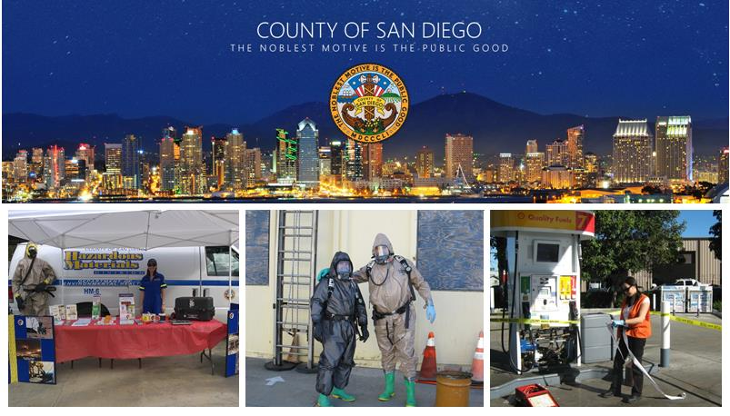
County of San Diego
Department of Environmental Health
PROGRAM COORDINATOR
Hazardous Materials Division Option
The County of San Diego is currently accepting job applications for Program Coordinator, to fill an immediate vacancy for the Department of Environmental Health, Hazardous Materials Division. Program Coordinators are responsible for providing administrative, analytical, and management support for programs and projects where substantive administrative, policy, and/or technical issues require specialized analysis, recommendation, and implementation. For additional information on this job classification, click here.

TO APPLY: Visit https://www.sandiegocounty.gov/hr/
Minimum Qualifications
A bachelor's degree from an accredited U.S. college or university, or certified foreign studies equivalency, AND, four (4) years of professional experience performing analysis, budget management, program administration, engineering, or closely related work in a program performing planning and analysis; OR a combination of education and/or experience as stated above.
Desirable Qualifications
The possession of the following valid certifications and registration are not required, but considered highly desirable at the time of application submittal:
- Current ICC (California UST Inspector) certification
- Current APSA (Aboveground Petroleum Storage Act) certification
- Registered Environmental Health Specialist (REHS) in the State of California
Evaluation
The names of qualified applicants will be placed on a twelve (12) month eligible list based on scores received during the evaluation of information contained in their employment and supplemental application. Please ensure all information is complete and accurate as the responses you provide on the supplemental application form will be reviewed using an automated evaluation system. If you are successful in the initial screening process, your application will be reviewed individually to confirm that the information you provided is accurate and qualifying.

Reasonable accommodation may be made to enable qualified individuals with disabilities to perform the essential functions of a job, on a case-by-case basis.

The County of San Diego and its employees embrace the Live Well San Diego vision: A region that is Building Better Health, Living Safely and Thriving. For more information www.livewellsd.org.

Under California Government Code Sections 3100 - 3109, public employees are designated as disaster service workers. The term "public employees" includes all persons employed by the state or any county, city, state agency, or public district. Disaster service workers are required to participate in such disaster service activities as may be assigned to them by their employer or by law.
The County of San Diego is committed to valuing diversity and practicing inclusion because our diverse workforce is our greatest asset and our customers are our number one priority.

APPLICATIONS MAY BE FILED ONLINE AT:  https://www.sandiegocounty.gov/hr/  5530 Overland Ave., Suite 210  San Diego, CA 92123  (619) 236-2191  (866) 880-9374  processunitemail.fgg@sdcounty.ca.gov | Position #19243702HMD  PROGRAM COORDINATOR-HMD-19243702HMD  CP

